**Scale Inventory Manager App V.2.2.11**

**Requirements:**

Java RE – version 6 or above  
Windows OS – version XP or above

**Installation:**

1.Unzip the folder ‘Scale Inventory’ (with its contents within) to the ‘C:\’ directory (so that all files are located on the path C:\Scale Inventory\...).

2.Create a shortcut on the Desktop (or whichever desired location) with the path: C:\Scale Inventory\Scale Inventory Manager 2.1.10 (alternatively copy the runnable jar file and paste a shortcut at the desired location)

3. Double-Click **Scale Inventory Manager V.2.2.11.jar** shortcut to start the application.

**User Manual:**

This application contains 5 panels (Figure 1). Here’s a general description of each panel function(s):

Panel 1: store preventive maintenance records  
Panel 2: view preventive maintenance records and generate an Excel spreadsheet  
Panel 3: View/Add/Edit Scale information  
Panel 4: View/Add/Edit workstation Information  
Panel 5: View/Add/Edit Repair Information

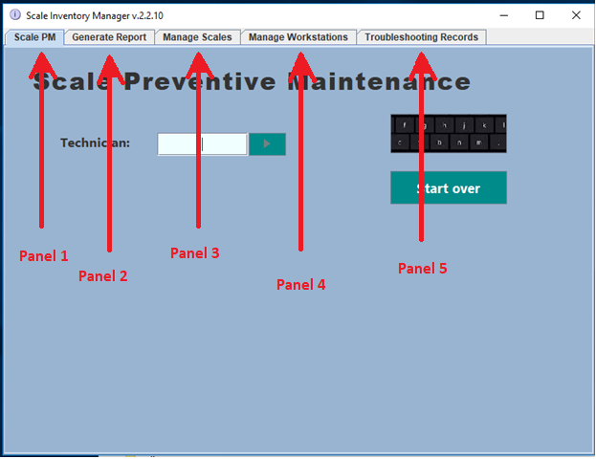

Figure 1: User Interface at Startup

**Panel 1:**

In this panel, a step-by-step process has to be followed to prevent issues and to not overwhelm the user with the many controls presented. Use Figure 2 to see the visual representation of the interface.

1. **Choose facility on the Site dropdown menu (1) and Identify technician by entering up to 10 characters** (2)
2. **Select department from list of departments on the database** (3)
3. **Select the workstation correspondent to the scale to be inspected** (4) (note that each scale is associated with an unique station name, normally the station is identified by PC connected to the scale, when this is not the case, the station is identified by area and/or by not being used for web applications such as SAP)
4. **Serial number verification** (5). The SN of the latest record on the database for that scale should be displayed, the user is asked to verify that the scale has that serial number as this number is responsible for identifying the scale. If the scale has been replaced or the SN has a typo, press ‘No’ otherwise press ‘Yes’. If ‘No’ was pressed the box containing the serial number becomes editable, once the correct serial number has been entered, press ‘Done’ to confirm. Next, the user will be prompt to enter the reason for changing the serial number (10), make a selection then press ‘Proceed’, if ‘Other reason’ is selected, a pop up window will ask the user to enter a custom response, if ‘Scale was replaced is selected, the user will be prompted to enter a reason for the replacement of the scale (11). Select reason, then press ‘Proceed’, select ‘Other reason’ for a custom answer.
5. **Enter reading from the scale and the weight used for inspection** (6) (default is 15lbs which is what is required by law for scales that process the weight to charge the customer).
6. **After scale reading is entered, the user must specify if an adjustment was required (6)**, i.e., if the initial reading was acceptable press ‘No’, otherwise press ‘Yes’ in order to enter what was the resolution for obtaining an acceptable reading (9) (<= 0.02 error) . Note that if scale had to be replaced, the new serial number has to be reported by restarting the process for which the button ‘start over’ is responsible for (8).
7. **Press ‘Next Scale’ to validate and submit all information entered (8)** and to restart the process without changing department or user identification. To start over from scratch use ‘Save and Exit’.

**At any time, the user may start from the very beginning by pressing ‘start over’ (8), however all information entered will be lost.**

**If an on-screen-keyboard is not available, the user may tap on the keyboard icon to open a windows on-screen keyboard, which is available in every panel.**

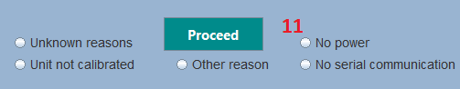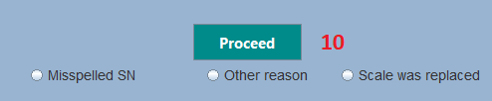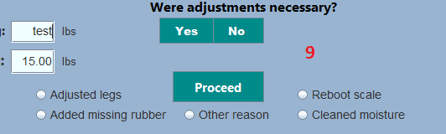 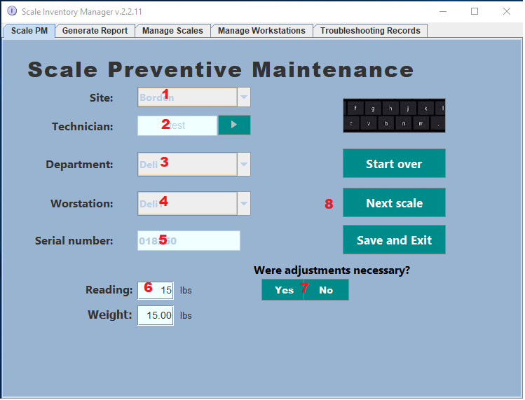  
  
Figure 2: The controls for processing a new PM record

**Panel 2:**

In this panel, the user can view the records for the PMs done in the past.

1. **Select type of report (1/9).** To see all records for a specific date, between 2 dates, or every record, select **Date repor**t. To see only records for a specific department, select **Department report**. To see records associated with a single workstation, select **Workstation report**. To see records only for a particular scale, select **Single Scale Report**.
2. Depending on the selection made before, a unique identifier will need to be selected, or a selection from the drop-down menu. **For Department report, choose a department**. **For workstation report, enter workstation name-code. For Single scale report, enter scale Serial Number. For date report, follow the instructions displayed in the green background.**
3. By default, scales not required to have a specific precision by law (since these are not used to charge customers) are not displayed in the report. **To display all scales inspected during preventive maintenance, toggle the box on control number 4**, otherwise skip this step.
4. **Press Get Report button (3) to display the report on the screen.**
5. **To create an Excel Spreadsheet with the information displayed on the screen, press Export to Excel button (5)**, then select a location in the device to save it, then edit the name of the file (optional; default is current date) without adding extension. When overwriting files, make sure that file being erased is not open in another program.

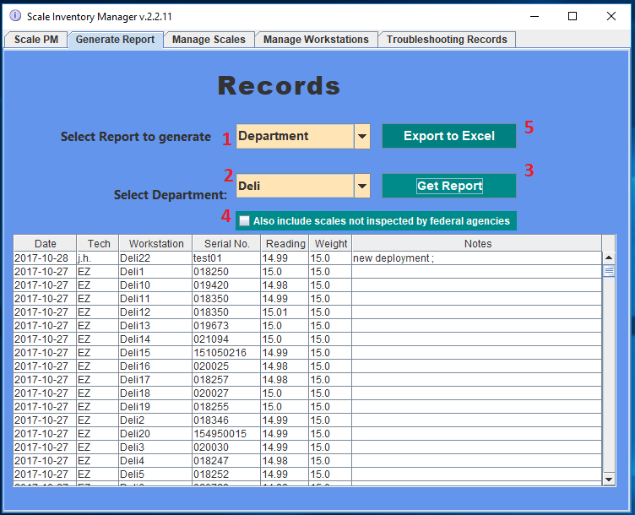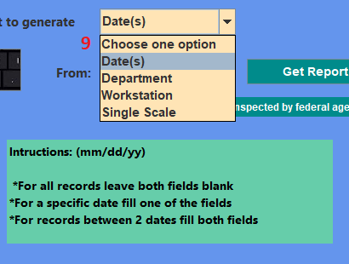

Figure 3: Report of scale PM measurements

**Panel 3**:

In this panel, the user can view all inventory of scales and the data attributed to each individual scale. This data can be modified or added by using the controls presented in Figure 4.

1. By default, all scales are being displayed, **the user may filter the records** by selecting **SAP scales** (1) to see only scales that require a specific precision by law, **NonSAP scales** for scales not presented in the first group and whose stray size is a square foot or over, **Low Capacity Scales** are small scales such as A&D SK-20KWP, CAS SW-1N and even smaller scales. Pressing **Refresh Table** button (2) is required to see a different category of scales after making the selection.

**Note**: The order of the scales is based on their condition primarily. On the top, scales whose condition is **Bad** are displayed, followed by **Check**, followed by **Shipped Out**, followed by **Good** and ending with **Decommissioned.** Scales of the same condition are ordered alphabetically. (More information on condition types on section 2.2).

1. **To modify information pertaining a scale in the records**, first check the quick actions dropdown for the desired modification. If not presented there, utilize the textboxes and dropdowns under “**Edit scale data**” (3) in the following manner:

2.1. **Add scale Serial Number** to the left-most textbox, when clicking out of this box all scale data is populated into these controls (3) (if there is a match). Alternatively, if SN is not available, use the 2nd textbox to enter the **Workstation** identifier associated with the desired scale in order to obtain the same result. (Required fields)

2.2. **The Condition of the scale** (10) is to be attributed in the following manner: **Bad** – known to contain problems and requires troubleshooting (ex: scale was replaced); **Check** – Scale that needs to be tested (ex: failed precision test during PM , came back from repair or just added to inventory); **Shipped Out** – Sent out for repair; **Good** – no issues; **Decommissioned** – cannot be repaired or has been disposed of. (Required field)  
  
**Note**: Prior to set scale as Shipped Out, it is recommended to first specify Manufacturer of unit so that a window will pop up containing the shipment information for that particular manufacturer.

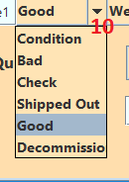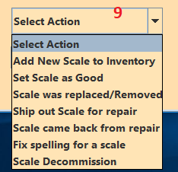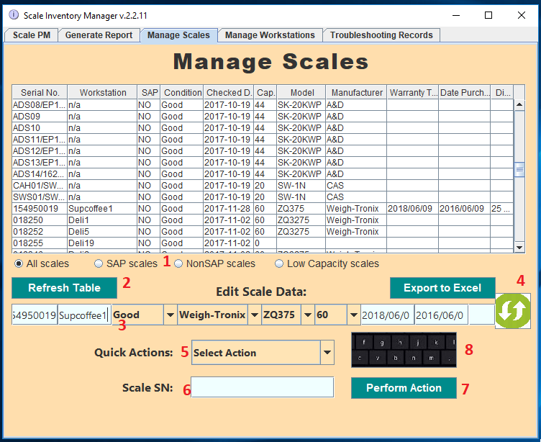

Figure 4: Inventory of scales and commands to edit scale data

2.3. **Set scale Model prior to manufacturer** as the program automatically sets the manufacturer based on the model selected. If model or manufacturer is not on the list, select other to be allowed to enter a different data.

2.4. **Select capacity** based on the options. If different from options shown, select Other to enter a different capacity.

2.5**. Enter purchase date** through the format MM|DD|YY or YYYY|MM|DD in which “I” can be any special character.

2.6. **Enter warranty termination date** through the format MM|DD|YY or YYYY|MM|DD in which “I” can be any special character.

2.7. **Enter scale dimensions** on the right-most textbox.

2.8. **Press the green button to update** the information of the scale. Press **Refresh Table** button (2) to view the modified information.

3. **The quick action dropdown (5) has 2 purposes**: perform some minor changes in scale data in an easier manner and perform actions not presented in the group of controls above it (3). Here are the options (9):

3.1. **Add new scale to Inventory**: use this when a new scale is added to the inventory. After selecting this option, type the **Serial Number** of the unit on the textbox (6), then press Perform Action. The scale **condition** is automatically set as **Check**.

3.2. **Set scale as Good**: use this after troubleshooting a scale down for repair that has been deemed ready to be deployed. After selecting this option, type the **Serial Number** of the unit on the textbox (6), then press **Perform Action** button.

3.3**. Scale was replaced / removed**: If this is observed at a different occasion other than when performing the pm, use this selection, then type **serial number** of the scale that was replaced (6), then press **Perform action** button (7). A popup window will appear to prompt the user to enter the **SN** of the scale that was installed. The scale that was removed will be attributed the **condition Bad.**

3.4. **Ship out Scale for repair**: Select this option when a scale is being sent to the manufacturer for repair, enter scale **serial number** on textbox (6), then press **Perform Action** button (7). It is recommended to have assigned a manufacturer to the scale to be repair prior to perform this action as a popup window will display the shipment information associated with that manufacturer. The **condition** of the scale is set as **Shipped Out**.

3.5. **Scale came back from repair**: Once scale comes back from the manufacturer, select this option, enter scale **serial number** on textbox (6), then press **Perform Action** button (7). Scale’s **condition** is set as **Check** as tenting is required prior to have the scale ready to be deployed.

3.6. **Fix spelling for a scale**: if a scale has a wrong serial number this option should be selected, enter current serial number on textbox (6), press **Perform Action** button (7) and a popup window will prompt the user to enter the correct serial number. Note that no action will occur if new serial number already exists in the inventory.

3.7. **Scale Decommission**: if scale cannot be repaired or is being disposed of select this option, enter scale **serial number** on textbox (6), then press **Perform Action** button (7). The status of the scale will be changed to **Decommissioned**.

4. **To create an Excel Spreadsheet with the information displayed on the screen, press Export to Excel button (4)**, then select a location in the device to save it, then edit the name of the file (optional; default is current date) without adding extension. When overwriting files, make sure that file being erased is not open in another program.

Panel 4:

Since every scale must be associated with a workstation, **this panel allow the users to add/edit/update and delete workstations**. There’s 3 types of workstations as seen on Figure 5. **Category 1** workstations are for scales that are connected via serial to a computer and will be responsible for handling the price that the customer is being charge. **Category 2** is for stations that have a scale but not a computer and we still need to perform PMs on these scales. **Category 3** are special workstations necessary to identify the location of the scales, such as ‘Parts Room’ or each individual Manufacturer/seller for when units need to be sent out for repair. ‘N/a’ is used only for small scales since these units are not PM’d.

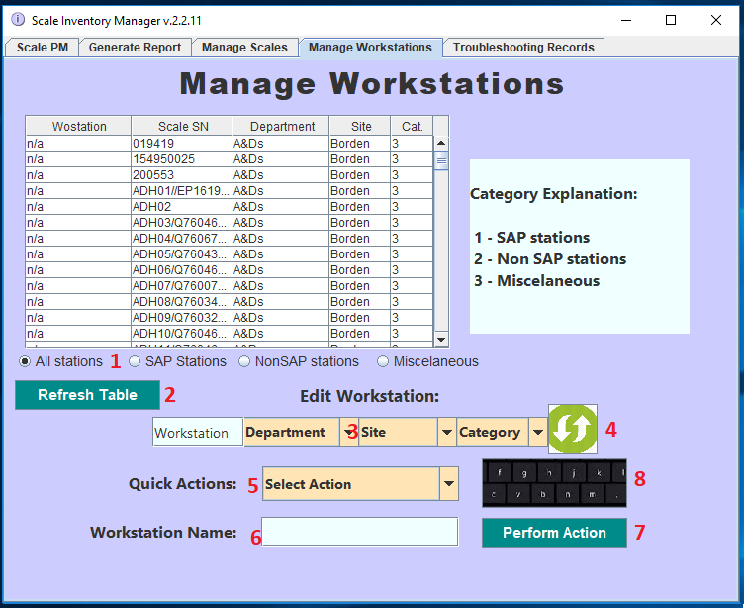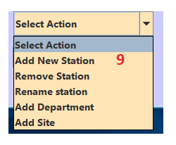

Figure 5: Manage workstations panel. Use this panel to Edit Workstations which is necessary to attribute a location to a scale

1. By default, All stations are being displayed. **To filter results**, select **SAP station**s for category 1 Workstations, **NonSAP stations** for category 2, **or Miscellaneous** for category 3 (1). After the selection is done, press **Refresh Table** button (2).
2. Similar to the previous panel**, first look for the action needed in the Quick Action drop down**. If not found here do the following:

2.1. **Type the Workstation unique name identifier on the textbox** below and left of the **“Edit Workstation**” title. When clicking somewhere else, the data about the Workstation is loaded into the dropdown menus (if matching unique identifier is found) (3).

2.2. Use the **Department** dropdown to select a (pre-existing) department.

2.3. Use the **Site** dropdown to select a (pre-existing) site (such as Borden or FDC).

2.4. Use the **Category** dropdown to select a category (1, 2 or 3).

2.5. Press the **green Update button** to update the information in the database (4), then press **Refresh Table** button (2) to see the changes made.

3. **Adding a new Workstation**: On the **Quick Action** dropdown select **Add New Station** (5,9). Type a unique workstation name (that hasn’t been used) on the textbox below (6). Press **Perform Action** button (7). You will be prompt to select a category for the new workstation, to cancel close the prompt.

4. **Remove Station**: If a station no longer has a scale hence it is not needed to be on the PM panel, on the **Quick Action** dropdown select **Remove Station** (5,9). Type the unique name for the desired station on the textbox below (6). Press **Perform Action** button (7), a prompt will ask to select option 1 or 2, select 1. If a workstation has been created by mistake and the user wants to delete it, select 2 at the prompt. Close the prompt window to cancel. Note that once a scale on a particular station has been PM’d, this station can no longer be completely removed.

5**. Rename a Workstation**: On the **Quick Action** dropdown select **Rename Station** (5,9). Type the unique name attributed to the workstation that the user wishes to rename on the textbox below (6). Press **Perform Action** button (7). You will be prompt to type the new name for the workstation, enter a unique name easily associated with the location of a scale and that hasn’t been used.

6. **Add a department or Site**: When creating a new department, an existing workstation (in the database) **must** be associated with the new department, and to create a new site an existing department (in the database) **must** be associated with the new Site. (On this stance note that once no workstation is associated with a department, that department ceases to exist in the database and once no Department is associated with a Site, that Site ceases to exist in the database**) The correct procedure for handling a new department and/or Site is as follows**:

6.1. Add at least 1 new workstation to the system that will be associated with the new department (and Site if that’s the case) by following S**tep 3**.

6.2. Add a new **departmen**t by selecting **Add Department** on the dropdown on the quick actions menu (5,9), enter the department name (which must be unique) on the textbox below (6), press the **Perform Action** button (7), you will be prompted to enter the unique name identifier for the station to be associated with the new department, enter the name of the workstation created in step **6.1..**

6.3. Add a new **Site** by selecting **Add Site** on the dropdown on the **Quick Actions** menu (5,9), enter the site name (which must be unique) on the textbox below (6), press the **Perform Action** button (7), you will be prompted to enter the unique name identifier for the department to be associated with the new site, enter the name of the department created in S**tep 6.2**..

6.4. Close the application and start it again (in order to have the dropdowns on the Edit controls contain the new department/site). To associate other workstations with the new department, or other departments with the new site (if that’s the case) now you can use the process followed in **Step 2**.

**Panel 5:**

This panel is to store and display the records for troubleshooting the scales. The user may create an initial record to which later may be updated as the unit is inspected and troubleshooted.

1. Initially all records are being displayed (1). The user may choose to filter in order to display only Scales connected to a computer by selecting **SAP Scales**, large scales not connected to a computer by **selecting NonSAP Scales**, or small scales by selecting **Low capacity scales**. Then it is necessary to press **Refresh Table** button (2) to show the records for the current selection.
2. To create a new record, the user has to check the bullet next to **New Record** (3), which will disable the Record# textbox. To update a pre-existing record, make sure that said bullet is unchecked, then enter the **Record#** on the textbox, then all the data for that record will be populated onto the textboxes and **Repair status** dropdown (4) after clicking outside of this textbox.
3. Enter the scale serial number on the **Scale SN** textbox. For low capacity units (**category 3**), use the codename provided followed by “/” followed by serial number (if available). (Required field)
4. Choose the repair status from the list (8): **Not inspected** when unit has just been checked in without initial observation. **In Progress** is to be set if symptom has been assessed but unit wasn’t fixed. **RMA requested** is set when manufacturer/seller has been contacted to check for the warranty status of the unit. **Shipped out** is to be set once unit was sent to manufacturer (this action will also change the Status attribute on the same unit on panel 3). **Completed** is to be set when troubleshooting has been concluded (this action doesn’t change the status of the unit on panel 3). (Required field)
5. Enter the Technician’s initials on the **Tech** textbox. (Required field)
6. Enter the date of when issue(s) have been reported for the first time on the scale (or when it was dropped at the office) on the **Down since** textbox. (Required Field)
7. When troubleshooting is concluded, enter the date on the **Repaired Date** textbox, if it’s the present date, select the bullet next to **Today** in order to make the present date appear on the **Repaired Date** textbox.
8. Enter the symptoms observed on the **Symptom(s**) textbox.
9. Enter the probable cause of the issue(s) observed on the **Root Cause(s**) textbox.
10. Describe how was the unit fixed on the **Resolution** textbox.
11. Press **Update Record** button to add the record (if New Record) or Update an existing record.
12. 4. **To create an Excel Spreadsheet with the information displayed on the screen, press Export to Excel button (6)**, then select a location in the device to save it, then edit the name of the file (optional; default is current date) without adding extension. When overwriting files, make sure that file being erased is not open in another program.

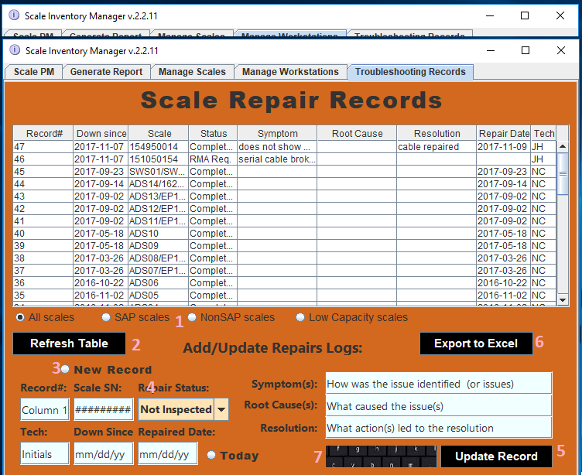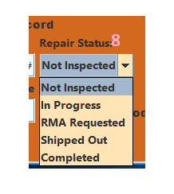

Figure 6: Viewing the Troubleshooting records on panel 5.